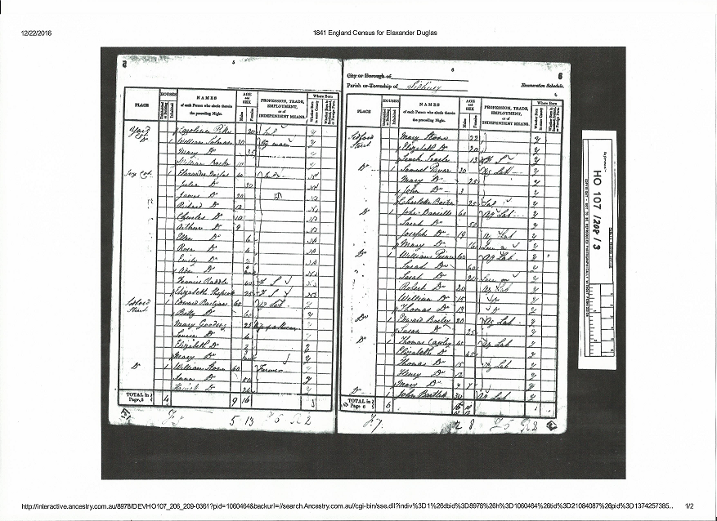
Elaxander Douglas (40)
Julia Douglas (30)
James (20)
Richard (18)
Charles (10)
Arthur (9)
Ellen (6)
Rosa (4)
Emily (2)
Ada (4 mths)

